Service for April 19, 2020

Prelude

https://www.youtube.com/watch?v=RY4CW5pte98&rel=0

Announcements

https://youtu.be/uwo1ERkFO84?rel=0

Greeting
Take a few minutes and call someone and let them know you are thinking about them and check in on them. Take a moment and ask God if there is someone in particular that you should reach out to and do it. If they have any particular needs that we as a church can help with, let us know. Otherwise, you may want to pray with them before you disconnect.

Scripture: Isaiah 44.1-4

https://youtu.be/p-mopL1n6Js?rel=0

Hymn: Love Divine, All Loves Excelling
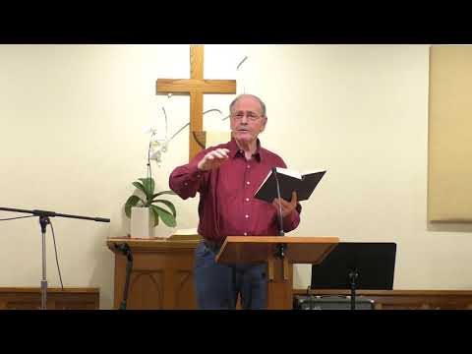
https://youtu.be/S13vrleZHnc?cc_load_policy=1&rel=0

Moment for Kids of All Ages

https://youtu.be/OL1wzuM4rl4?rel=0

Prayer

https://youtu.be/N8LZdF9USdw?rel=0

Special Music

Thanks Eysters for sharing your gifts!
If you wish to make your offering at this time, you can do so at https://app.easytithe.com/App/Giving/dbic
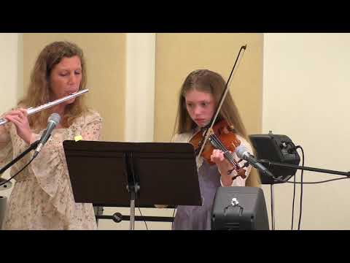
https://youtu.be/WDqq2EtqI8s?rel=0

Hymn: I Stand Amazed in the Presence
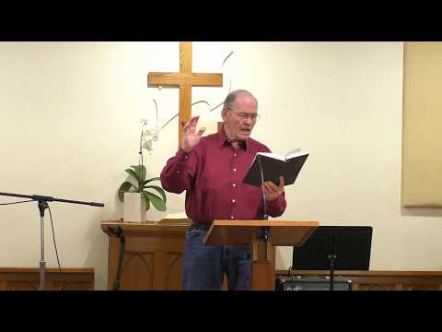
https://youtu.be/hjHWf0LUp7c?cc_load_policy=1&rel=0

Sermon

https://youtu.be/kpU5EHMQs5I?rel=0

Worship
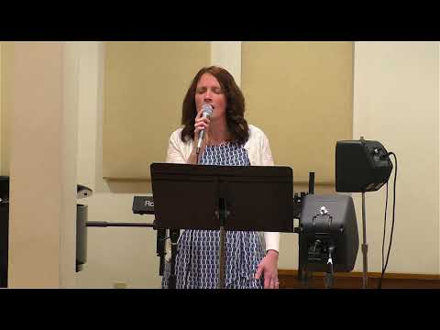
https://youtu.be/RECduQfC2yU?cc_load_policy=1&rel=0

Some additional Links

Powerpoint Link
https://www.dillsburgbic.org/hp_wordpress/wp-content/uploads/2020/04/Message_Slides_041920.pdf
Questions for Conversation (Small Groups)
https://www.dillsburgbic.org/hp_wordpress/wp-content/uploads/2020/04/Questions-for-041920.pdf

