November 1, 2020

Welcome and Announcements
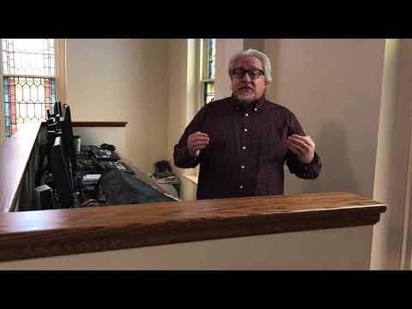
https://www.youtube.com/watch?v=WQ2hh5w6GHo

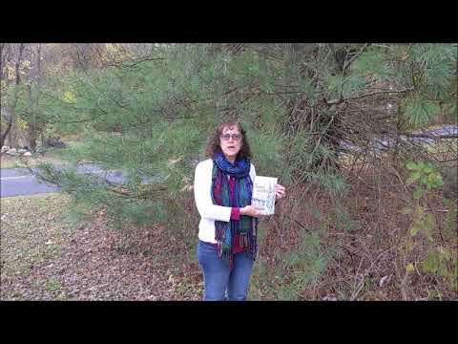
https://www.youtube.com/watch?v=S4_oFWo4ma4

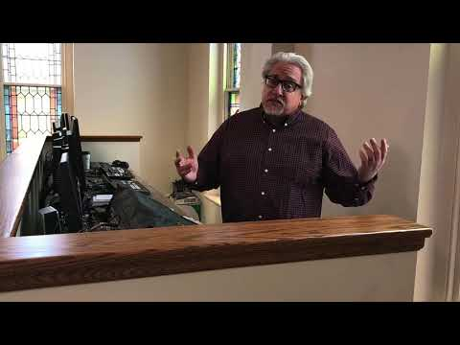
https://www.youtube.com/watch?v=EJsIOgFuCQc

Greeting
This week, check in with two different people or households. One should be from DBIC and the other should be someone you know who doesn’t go to DBIC. Ideally, this second connection would be with someone who does not go to any church. Tell them you are thinking about them, and see if they have any particular needs that we as a church can help with, then let us know.

Scripture – Psalm 66:1-20
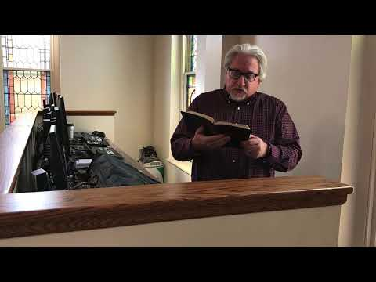
https://www.youtube.com/watch?v=x-qzNi4O3f0

Hymn We Gather Together
In some ways this is a strange hymn to be singing while we are apart. But we are gathering in Christ today even if we cannot take up the same space. All of the things mentioned in this song still apply to us as we seek to follow Christ.
(Enable closed captions for the lyrics)
https://youtu.be/WORZ2xFKLA8

Moment for Kids of All Ages
https://www.youtube.com/watch?v=Wd4HIKw0PMU

Prayer
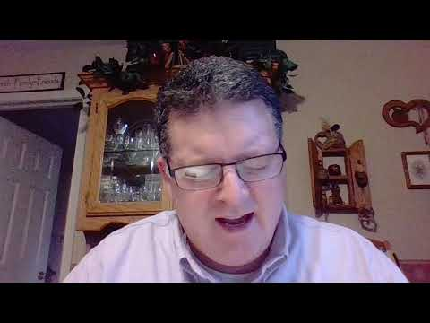
https://www.youtube.com/watch?v=y5H1Kd3salY

Hymn Be Thou My Vision
Be Thou My Vision is a wonderful poem from the middle ages in Ireland. It is asking God to be our everything.
https://youtu.be/LmsWNEH6acs

Praying for the Persecuted Church
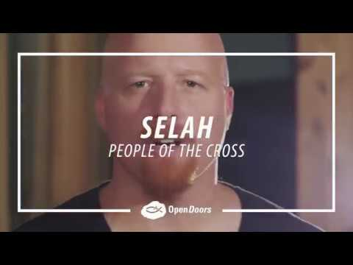
https://www.youtube.com/watch?v=O5XM6VZxgeM

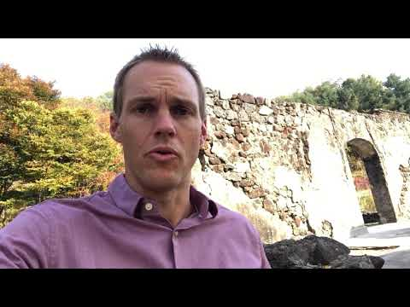
https://www.youtube.com/watch?v=lex8zR_2I7M

Message
Sorry for the less-than excellent video quality.
Sermon slides are available at https://www.dillsburgbic.org/hp_wordpress/wp-content/uploads/2020/11/sermon_slides_for_november_1_2020.pdf
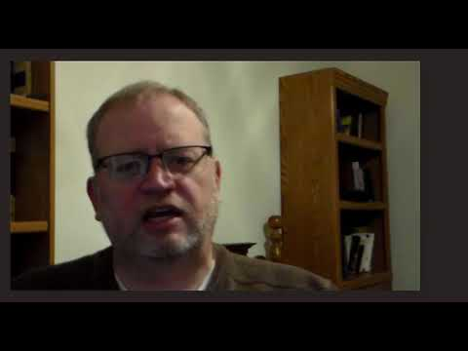
https://www.youtube.com/watch?v=Q_7fpyeqPi0

Additional Resources:
Question for Small Groups are available at https://www.dillsburgbic.org/questions-for-conversations/
Sermon Slides: https://www.dillsburgbic.org/hp_wordpress/wp-content/uploads/2020/11/sermon_slides_for_november_1_2020.pdf

