Service for May 31, 2020

While we are moving beyond the Holy Spirit this week as the focus of our topic, do not forget that today is Pentecost.
Spend a moment giving thanks to God for the gift of the Holy Spirit. Spend a moment asking the Holy Spirit to take up more space in your life.

Prelude
In light of all that is going on, join your hearts with these words, as we cry out to God.
This video cannot be embedded. However, you can watch it at the link below.
https://www.youtube.com/watch?v=2-GTJ3i2xtw&rel=0

Announcements
https://youtu.be/zzIZ6AK9EN8?rel=0

Greeting
Connect with someone whose last name begins with the letter after yours. You may skip a letter if needed (we don’t have many with last names that begins with an X).
If you or someone you connect with has any particular needs that we as a church can help with, let us know.

Scripture: Psalm 30
https://youtu.be/WSCXXbo2uWA?rel=0

Hymn: Praise to the Lord
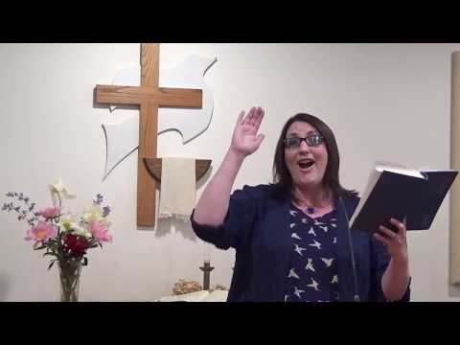
https://youtu.be/gYGZha9cOo0?cc_load_policy=1&rel=0

Moment for Kids of All Ages
This video cannot be embedded. However, you can watch it at the link below.
https://youtu.be/hyTJ8uBnJ60?rel=0

Prayer
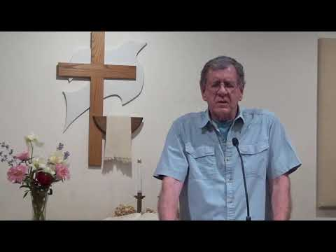
https://youtu.be/8z1lujVdC8o?rel=0

Special Music
Thanks to Randy Zwally for sharing his amazing ability. RZ always helps us have a good time.
If you wish to make your offering at this time, you can do so at https://app.easytithe.com/App/Giving/dbic
https://youtu.be/LqQR3gYdgQY?rel=0

Hymn: My Faith Looks Up to Thee
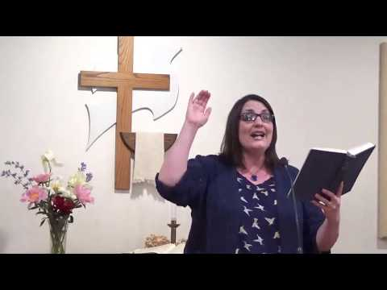
https://youtu.be/cgyXzFVgqDM?cc_load_policy=1&rel=0

Sermon
https://youtu.be/ieJLca5xSA0?rel=0

Worship
This is our first week of having Travis Moyer lead worship vocally. He does a great job in this set.
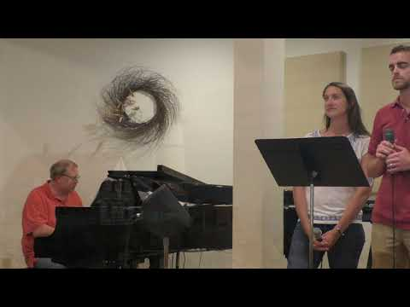
https://youtu.be/VtZkmSDOgOU?cc_load_policy=1&rel=0

Some additional Links

Powerpoint Link
https://www.dillsburgbic.org/hp_wordpress/wp-content/uploads/2020/05/Sermon-Slides-for-May-31-2020.pdf
Questions for Conversation (Small Groups)
https://www.dillsburgbic.org/hp_wordpress/wp-content/uploads/2020/05/Questions-for-Conversations-for-May-31-2020.pdf
Sermon Outline
https://www.dillsburgbic.org/hp_wordpress/wp-content/uploads/2020/05/Sermon-Outline-for-May-31-2020.pdf

