Service for May 24, 2020

This is the last week before Pentecost in the liturgical calendar, when we celebrate the coming of the Holy Spirit. This week we are focusing on the victory, joy, and freedom we have in the Holy Spirit.

Prelude
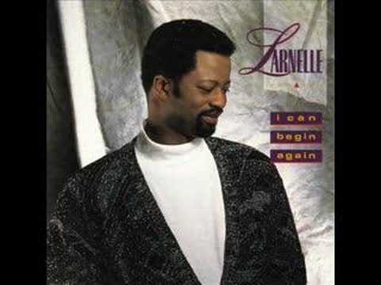
https://www.youtube.com/watch?v=Pu4zp6xjJAk&rel=0

Announcements
https://youtu.be/yGAl1SSmCz4?rel=0

Greeting
Please continue to reach out to those most at risk of being isolated. It is a great way to use the new contact list.
If you or someone you connect with have any particular needs that we as a church can help with, let us know.

A Word about our Direction
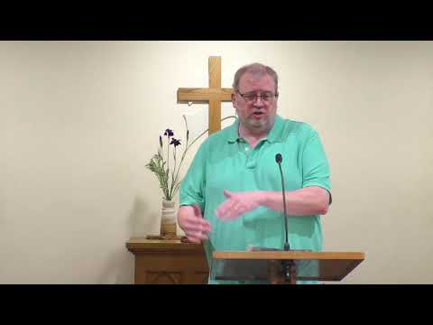
https://youtu.be/TNiPvjkCeTg?rel=0

Scripture: Psalm 20:
https://youtu.be/vVlFnxVDoKw?rel=0

Hymn: Joy to the World
When Isaac Watts wrote Joy to the World, he was not intending to write a Christmas song. In fact, while the song celebrates the results of Christ’s coming to earth, there is nothing in the song specifically about the incarnation.
In light of our focus for the week, it seemed fitting to rejoice with this song.
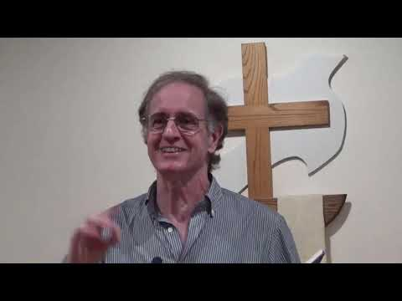
https://youtu.be/mXkhJMFZnwQ?cc_load_policy=1&rel=0

Moment for Kids of All Ages
A special thanks to Miss Dianne (and Ron) for putting together another video even though she is dealing with the covid virus. Please be in prayer for a full and speedy recovery. THANKS DIANNE!!!
https://youtu.be/EWOxzGp_iXs?rel=0

Prayer
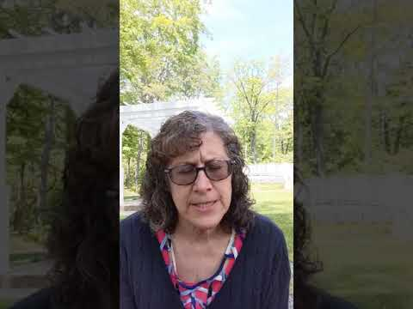
https://youtu.be/hk0FvNy-Rlg?rel=0

Special Music
Thanks to Jess and Elizabeth Hatch. They get the prize for people who don’t take themselves too seriously. Thanks for sharing both your talent and your joy!
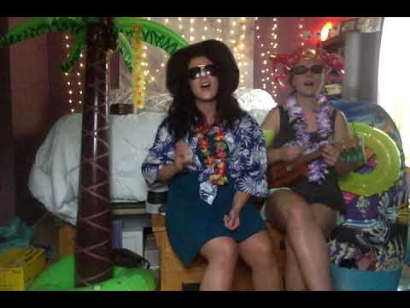

https://youtu.be/q0iD9OCuTrE?rel=0

Hymn: Victory in Jesus
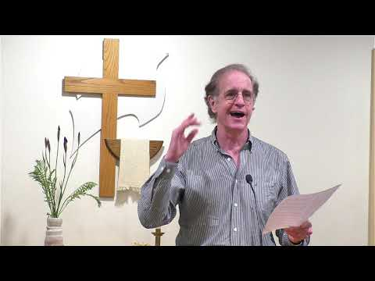
https://youtu.be/OnakPAHn8_s?cc_load_policy=1&rel=0

Sermon
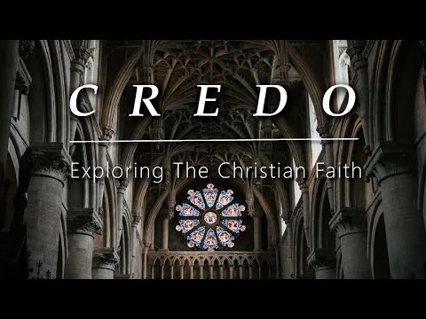
https://youtu.be/sps7NFEIotg?rel=0

Worship
We are providing you what we have for this section. One camera ran out of memory after the first two songs. The second camera only recorded the third song. So, while we are glad to have video of all of the music, there are not multiple camera angles available nor are all of the shots necessarily ideal.
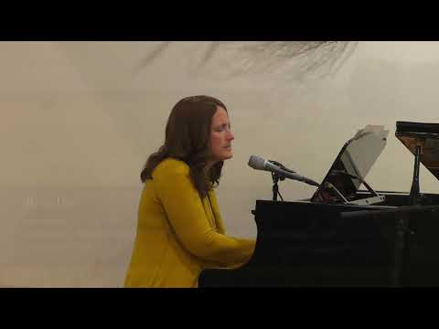
https://youtu.be/8EevUWl6lnQ?cc_load_policy=1&rel=0

Some additional Links

Powerpoint Link: https://www.dillsburgbic.org/hp_wordpress/wp-content/uploads/2020/05/Sermon-Slides-for-May-24-2020.pdf
Sermon Outline: https://www.dillsburgbic.org/hp_wordpress/wp-content/uploads/2020/05/Sermon-Outline-for-May-24-2020.pdf
Questions for Conversation (Small Groups) : https://www.dillsburgbic.org/hp_wordpress/wp-content/uploads/2020/05/Questions-for-Conversations-for-May-24-2020.pdf

