Service for May 17, 2020

Prelude
Our Prelude this week is a song that Randy Zwally had prepared a couple of weeks ago for special music. The video was accidentally forgotten when the service was assembled. We thank Randy for sharing his gift and for his understanding.
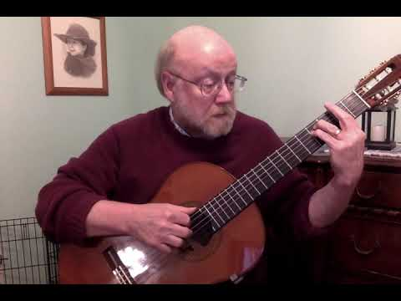
https://youtu.be/VMYPxHuG7h0?rel=0

Announcements
https://youtu.be/CUKR0kDPbUg?rel=0

Greeting
Last week, we distributed the most recent directory list. Use it to connect with someone you haven’t talked to in a while, or introduce yourself to someone you don’t know.
If they have any particular needs that we as a church can help with, let us know. Otherwise, you may want to pray with them before you disconnect.

Scripture: Psalm 98:
https://youtu.be/QhNpNE_BP54?rel=0

Hymn: I Sing the Mighty Power of God
In what seems like the never-ending unexplained technical issues. There is no video for the hymns this week. Thanks to Susan, Jan, and Ray for recording the hymns. Enjoy the pictures this week.
https://youtu.be/u_H9qwn_Acc?cc_load_policy=1&rel=0

Moment for Kids of All Ages
https://youtu.be/n-RY_Jzs2rg?rel=0

Prayer
https://youtu.be/OfWYBxIT85g?rel=0

Special Music
Thanks to Allie and Meredith Engle.
If you wish to make your offering at this time, you can do so at https://app.easytithe.com/App/Giving/dbic
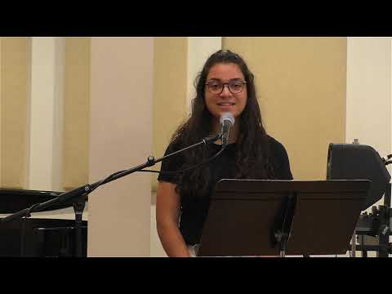
https://youtu.be/Ql6G9AkGXto?rel=0

Hymn: O God Our Help in Ages Past
https://youtu.be/EeinRJr3vt4?cc_load_policy=1&rel=0

Sermon
https://youtu.be/iMqz_BG8fSw?rel=0

Worship
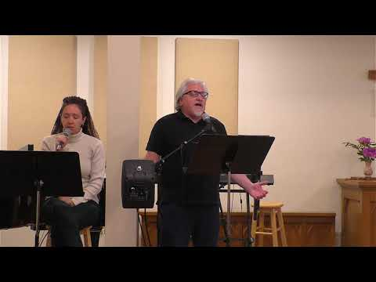
https://youtu.be/-d7yoMTmxSk?cc_load_policy=1&rel=0

Some Additional Links

Powerpoint Slides
https://www.dillsburgbic.org/hp_wordpress/wp-content/uploads/2020/05/Sermon-Slides-for-May-17-2020.pdf

Questions for Conversation (Small Groups)
https://www.dillsburgbic.org/hp_wordpress/wp-content/uploads/2020/05/Questions-for-Conversations-for-May-17-2020.pdf
Sermon Outline
https://www.dillsburgbic.org/hp_wordpress/wp-content/uploads/2020/05/Sermon-Outline-for-May-17-2020.pdf

