Service for May 10, 2020

Prelude
This video cannot be embedded in the Word document; however, you can still watch it at the link below.
https://youtu.be/OIahc83Kvp4?rel=0

Announcements
https://youtu.be/7voH1Q6Tyas?rel=0

Greeting
Follow Pastor Jeff’s guidance for the greeting. Reach out to someone who has played a mother-role in your life and thank them and bless them.
If they have any particular needs that we as a church can help with, let us know. Otherwise, you may want to pray with them before you disconnect.

Special Announcement about Family Promise (outtakes can be viewed below)
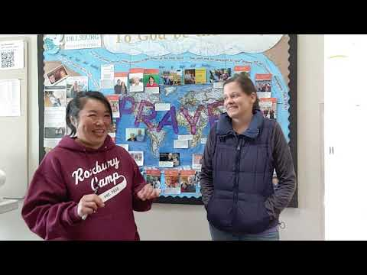
https://youtu.be/GW9sn7v-390?rel=0

Scripture: Psalm 33.1-9
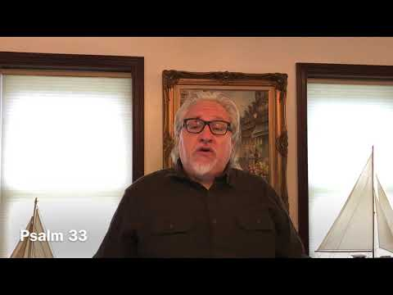
https://youtu.be/3zeYPy-ElIY?rel=0

Hymn: A Mighty Fortress
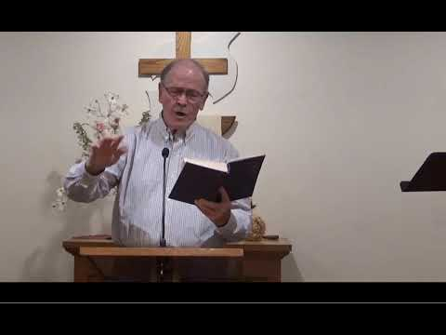
https://youtu.be/ATSe4zEVv3w?rel=0&cc_load_policy=1

Moment for Kids of All Ages
https://youtu.be/4BiazcIguFM?rel=0

Prayer
https://youtu.be/d8DerKL8PmM?rel=0

Special Music

Thanks Esther, Faithe and Jim for providing music for us this week.
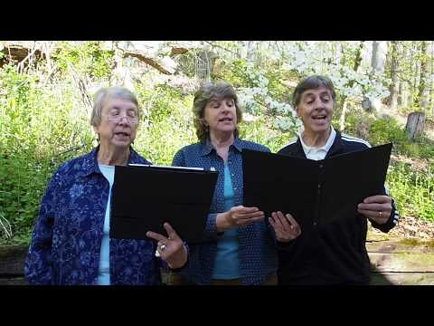
https://youtu.be/Lm-ldCqwHOs?rel=0

Hymn – This is My Father’s World

This video cannot be embedded; however, you can watch it at the link below.
https://youtu.be/FRcxynlDi0M?rel=0&cc_load_policy=1

Sermon
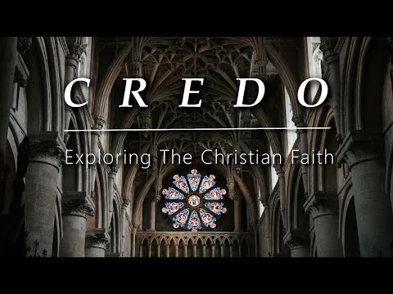
https://youtu.be/lMz5TUA5z-g?rel=0

Worship
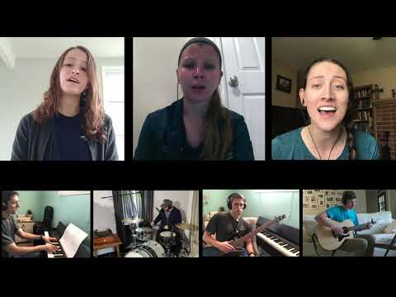
https://youtu.be/VjH2fEysgSc?rel=0&cc_load_policy=1

Some additional Links

Outtakes of Family Promise Announcement
https://youtu.be/fV7mH61JOUk?rel=0

Powerpoint Link: https://www.dillsburgbic.org/hp_wordpress/wp-content/uploads/2020/05/Sermon-Slides-for-May-10-2020.pdf

Questions for Conversation (Small Groups): https://www.dillsburgbic.org/hp_wordpress/wp-content/uploads/2020/05/Questions-for-Conversations-for-May-10-2020.pdf

