Worhip Service for May 3, 2020

Preparing for our Time Together
This video cannot be embedded. Please watch it through the link.
https://youtu.be/EqsnGE3_dsg?rel=0

Message from Leadership Council
https://youtu.be/y9pDSwLdn6k?rel=0

Announcements
https://youtu.be/YZ9HdvnyeHQ?rel=0

Greeting
This week, check in with two different people or households. One should be from DBIC and the other should be someone you know who doesn’t go to DBIC. Ideally, this second connection would be with someone who does not go to any church. Tell them you are thinking about them, and see if they have any particular needs that we as a church can help with, then let us know.

Scripture
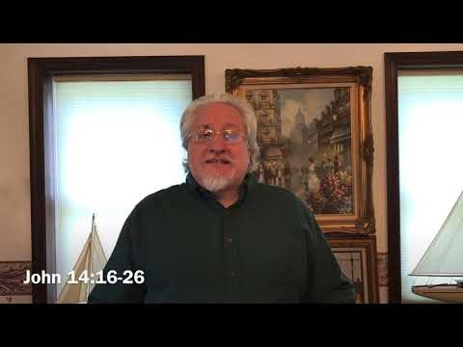
https://youtu.be/X-ycGvoAV9U?rel=0

Hymn We Gather Together
In some ways this is a strange hymn to be singing while we are apart. But we are gathering in Christ today even if we cannot take up the same space. All of the things mentioned in this song still apply to us as we seek to follow Christ.
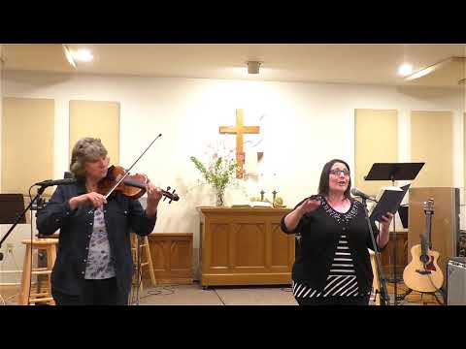
https://youtu.be/WORZ2xFKLA8?rel=0&cc_load_policy=1

Moment of Kids of All Ages
Thanks Rudy’s for sharing your gifts!
https://youtu.be/jwZdwS03iaI?rel=0

Prayer
https://youtu.be/_B-h76NMofs?rel=0

Worship
When we gather in person, we try to rotate the musical elements of our worship so that the kids experience the variety that we have at DBIC before they are dismissed for the children’s programs. I thought I would move it to keep is accustomed to the change. Actually, I moved it because Be Thou My Vision is such a beautiful song and fitting conclusion to the service.
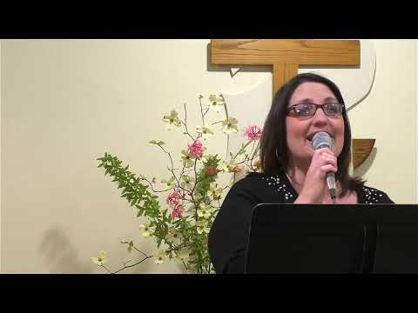
https://youtu.be/DzeidTAJrGo?cc_load_policy=1&rel=0

Offering
If you wish to make your offering at this time, you can do so at https://app.easytithe.com/App/Giving/dbic

Message
Part 1
https://youtu.be/6KCOLikockE?rel=0

Part 2: Hearing God
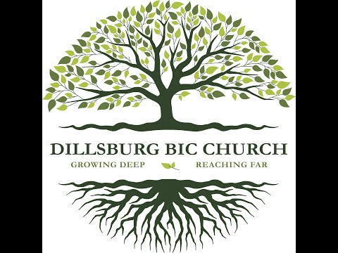
https://youtu.be/qQr4b1tAI58?rel=0

Part 3
https://youtu.be/57Y0yF0Fjds?rel=0

Part 4: Hearing God in Covid-19
https://www.youtube.com/watch?v=Pp98cK4YIoM&rel=0

Hymn Be Thou My Vision
Be Thou My Vision is a wonderful poem from the middle ages in Ireland. It is asking God to be our everything. The middle verse that is left out of our (and most) hymnals is a prayer about spiritual warfare:
Be Thou my Breastplate, my Sword for the fight;
Be Thou my whole Armor, be Thou my true Might;
Be Thou my soul's Shelter, be Thou my strong Tow’r,
O raise Thou me heav’nward, great Pow’r of my pow’r

As we conclude our service this week on the Holy Spirit, remember that he is our true might and the great Power of our power.
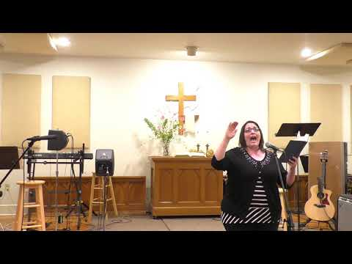
https://youtu.be/LmsWNEH6acs?cc_load_policy=1&rel=0

Additional Links
Of course, the week that I point out these additional links is the week that I have the least amount to offer you.

Link for Questions for Conversations : https://www.dillsburgbic.org/hp_wordpress/wp-content/uploads/2020/05/Questions-for-Contemplation-and-Conversation-for-May-3-2020.pdf

