Service for April 26, 2020

Prelude
To see the prelude, you will have to follow the link as this video cannot be embedded.
https://youtu.be/1vUhwyjdk8A?rel=0

Announcements
https://youtu.be/96nCqS2lxHg?rel=0

Greeting
This week, choose someone who you think is the least likely to be connected with this week. It doesn’t even have to be someone who regularly attends DBIC. From what we have heard so far, this has been an extremely meaningful time for people in the congregation.
If they have any particular needs that we as a church can help with, let us know. Otherwise, you may want to pray with them before you disconnect.

Scripture: Ezekiel 37:1-14

https://youtu.be/4K-QmpeaATg?rel=0

Hymn: Man of Sorrows, What a Name
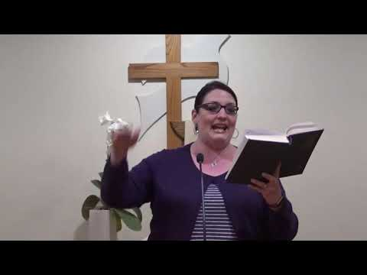
https://youtu.be/jKF4Vm7i_Gs?cc_load_policy=1&rel=0

Moment for Kids of All Ages
https://youtu.be/qxMwV7Ztc1Y?rel=0

Prayer
https://youtu.be/4fGCSk343Ik?rel=0

Special Music

We are grateful to have brother and sister team provide special music. Thanks Jordyn and Chris.

If you wish to make your offering at this time, you can do so at https://app.easytithe.com/App/Giving/dbic
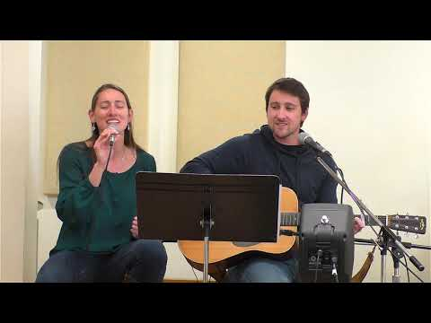
https://youtu.be/VgRt2USIufI?rel=0

Hymn: Children of the Heavenly Father
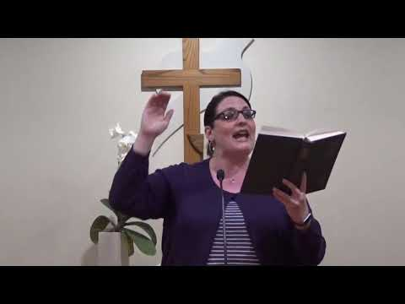
https://youtu.be/_TSqL2OW5vQ?cc_load_policy=1&rel=0

Sermon
https://youtu.be/_sY7eADpB28?rel=0

Worship (with some bloopers for fun)
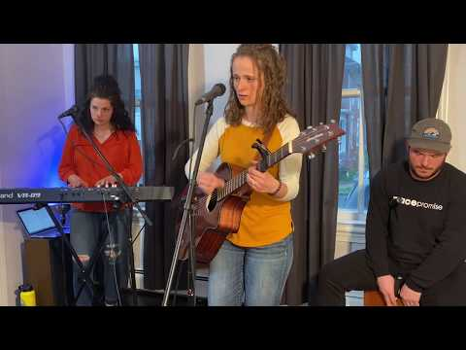
https://youtu.be/vAj7plTqa1U?rel=0&cc_load_policy=1

Some additional Links

Powerpoint Link
https://www.dillsburgbic.org/hp_wordpress/wp-content/uploads/2020/04/Message_Slides_042620.pdf

Questions for Conversation (Small Groups)
https://www.dillsburgbic.org/hp_wordpress/wp-content/uploads/2020/04/Questions_for_042620.pdf
Sermon Outline in Word Format
https://www.dillsburgbic.org/hp_wordpress/wp-content/uploads/2020/04/Outline_for_042620.docx

More Worship Bloopers
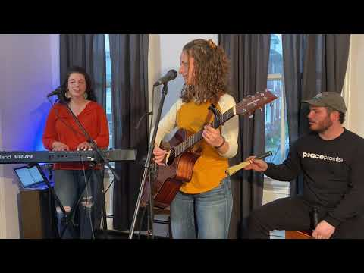
https://youtu.be/46kzkQvL4_w?rel=0

