Easter Service
April 12, 2020

Prelude
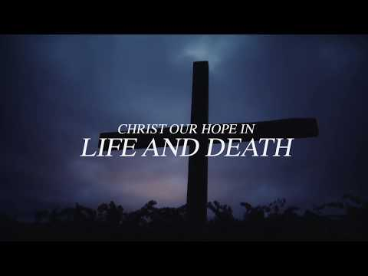
https://www.youtube.com/watch?v=OibIi1rz7mw&rel=0

Call to Worship
https://youtu.be/5FaXXhIonq4?rel=0

Announcements
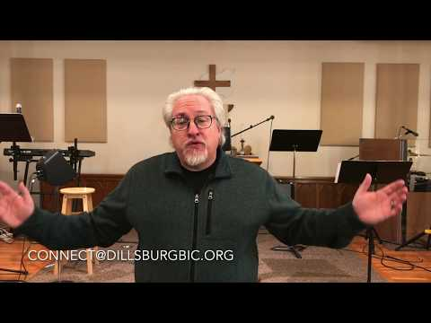
https://youtu.be/7Tnrb1H5__M?rel=0

Scripture John 20
https://youtu.be/NMwu-oWGpsw?rel=0

Hymn: Low in the Grave He Lay
(Please note the special cameo appearance by Grace Holland’s beautiful orchid. She allowed us to borrow it to help beautify the sanctuary.)
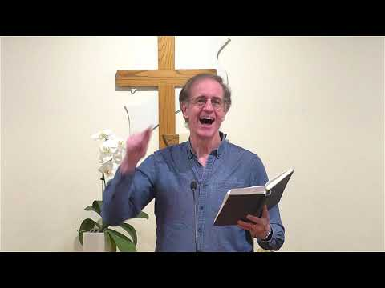
https://youtu.be/iC1bXqsvCrU?cc_load_policy=1&rel=0

Prayer
https://youtu.be/50FwOct5a9w?rel=0

Hymn: Because He Lives
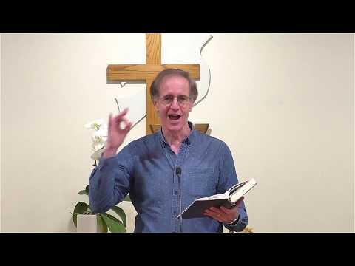
https://youtu.be/a_xLciDm7Lo?cc_load_policy=1&rel=0

Special Music
Thanks to Rachel Pease for responding to my request for special music.
If you wish to make your offering at this time, you can do so at https://app.easytithe.com/App/Giving/dbic

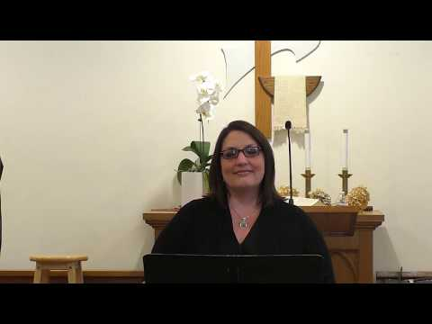
https://youtu.be/Q_LKIOAfVfI?rel=0

Hymn Christ the Lord is Risen Today
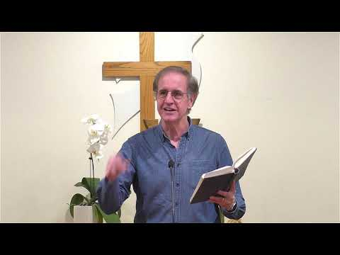
https://youtu.be/R1aJHdpI8Rk?cc_load_policy=1&rel=0

Message
https://youtu.be/0OEtPGtePHE?rel=0

Worship
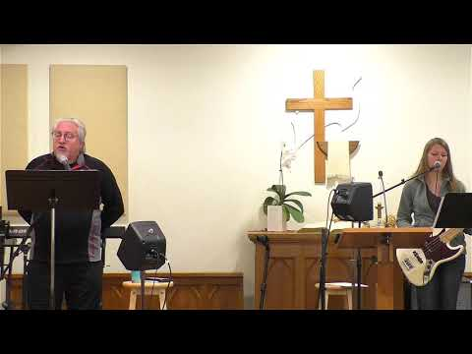
https://youtu.be/wH7OVgllUjM?cc_load_policy=1&rel=0

Benediction
https://www.youtube.com/watch?v=Zp6aygmvzM4&rel=0

