Service for April 5, 2020
Palm Sunday

Prelude
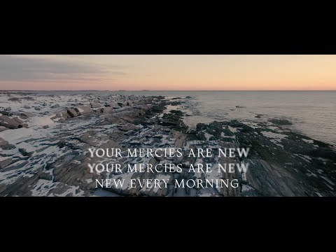
https://www.youtube.com/watch?v=Grz3Hxw9GWU&rel=0

Announcements
https://www.youtube.com/watch?v=LyQ6EksgSs4&rel=0

Greeting
Take a few minutes and call someone and let them know you are thinking about them and check in on them. Take a moment and ask God if there is someone in particular that you should reach out to and do it. If they have any particular needs that we as a church can help with, let us know. Otherwise, you may want to pray with them before you disconnect.

Scripture: Psalm 118:19-29
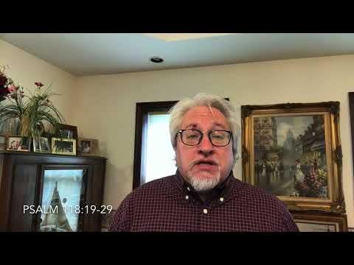

https://www.youtube.com/watch?v=glHd9_nqPpg&rel=0

Hymn: Hosanna, Loud Hosanna
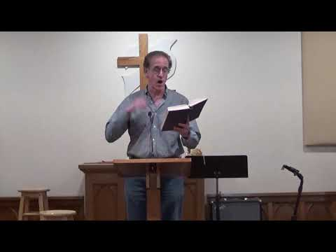

https://youtu.be/0gsIoO_bjUE?cc_load_policy=1&rel=0

Prayer
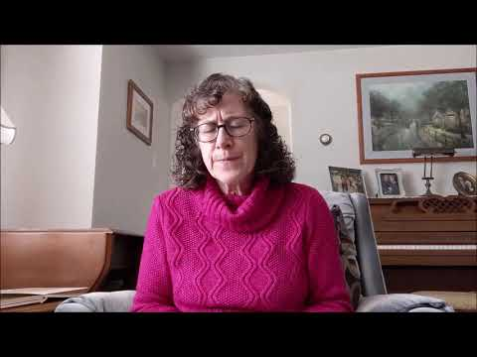

https://youtu.be/WucCMqeb0Sc?rel=0

Special Music

Thanks Jake for doing this for us and sharing it with us!
If you wish to make your offering at this time, you can do so at https://app.easytithe.com/App/Giving/dbic

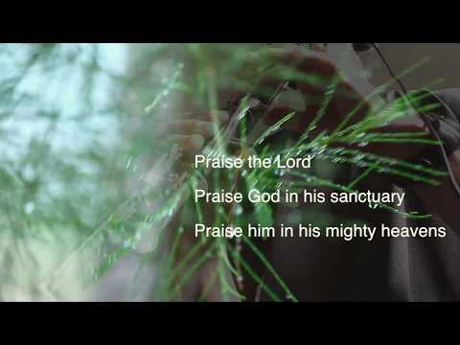
https://www.youtube.com/watch?v=hHxgPbIHPZk&rel=0

Just for Kids
(But nosey adults can watch too)
https://youtu.be/dhS0Fizi-mY?rel=0

Hymn: In the Cross of Christ I Glory
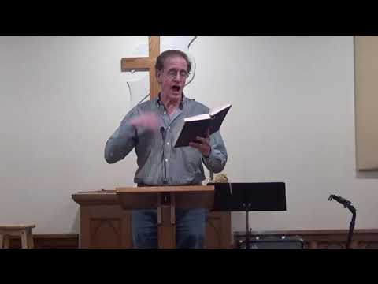

https://youtu.be/BSO8lQxVDGE?cc_load_policy=1&rel=0

Sermon

https://youtu.be/71UumBwDTws?rel=0

Worship
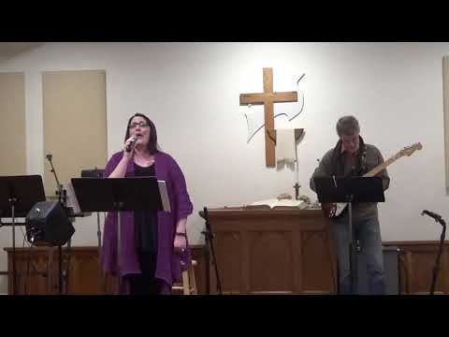

https://youtu.be/KIFsuVTANdk?cc_load_policy=1&rel=0

Some additional Links

Sermon Slides
https://www.dillsburgbic.org/hp_wordpress/wp-content/uploads/2020/04/Message_Slides_040520.pdf
Questions for Conversation (Small Groups)
https://www.dillsburgbic.org/hp_wordpress/wp-content/uploads/2020/04/Questions-for-Conversations-040520.pdf

